Night-by-Night Shelter Guide

Purpose: This guide will demonstrate the work flow for night-by-night shelter entry/exits and ShelterPoint bed check-in/reservations for night-by-night emergency shelters and cold weather shelters.
Please be reminded that once a client is checked into your program/shelter you do not need to exit them until 5 days have elapsed that they have not returned to shelter. At that point, an exit date/exit assessment can be made for the client. If you have the exact date the client last checked into the program that will be your exit date you enter into the client profile in HMIS.
Below is an example work flow for a night-by-night shelter entry.

- A client checks into shelter on 01/08/2021. You should create an entry under the client’s profile along with completing the entry assessment. (If a profile has not been created, please follow the workflow for creating a new client within HMIS)
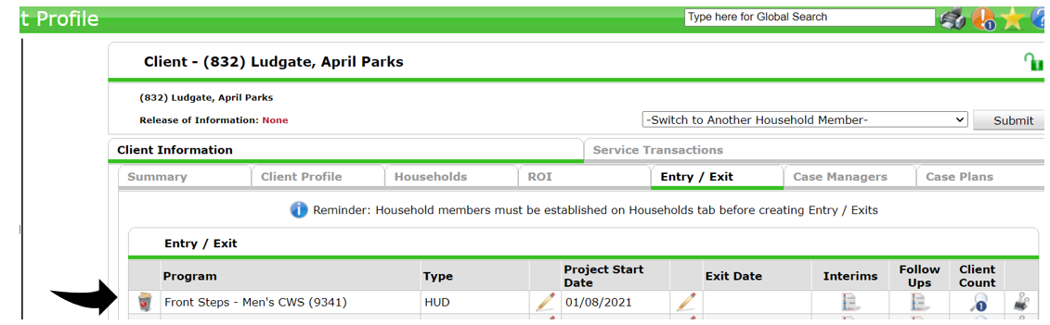

- Next, you want to check the client into an empty bed within ShelterPoint. (You want to be sure that your ShelterPoint check-in date matches your entry date that was entered in ClientPoint for the client.)
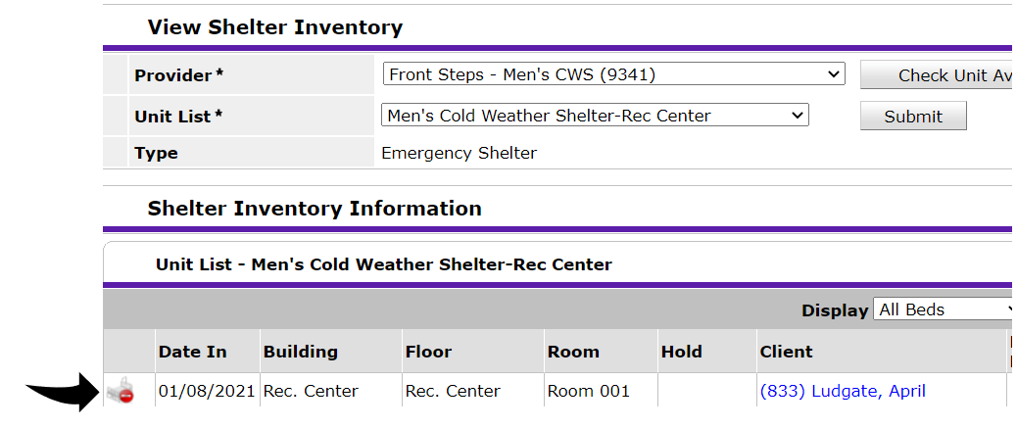
- Even if the client does not return to the Cold Weather Shelter the next night, you should keep the client’s entry open for several days in case the client does return. We want to avoid creating an entry and exit for every night a client comes to shelter.

For this example, we will say the client returned to shelter every night from the date of their entry 01/08/2021 through 01/12/2021 and then does not return to shelter for five days.

After those five days, you will then create an exit date and complete the exit assessment for the client. You will use the most recent date that they checked into shelter for their exit date which would be 01/12/2021.
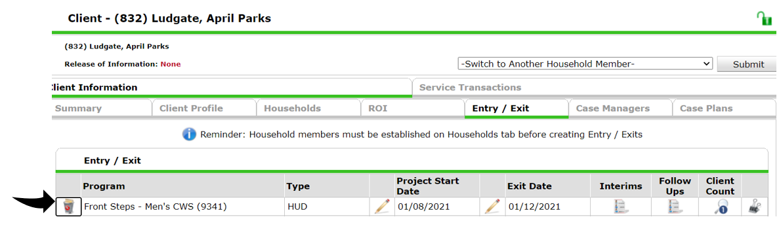
- You will also check the client out of their bed from ShelterPoint also using the last date the client stayed in shelter 01/12/2021. (You want to be sure that your ShelterPoint check-out date matches your exit date that was entered in ClientPoint for the client.)
