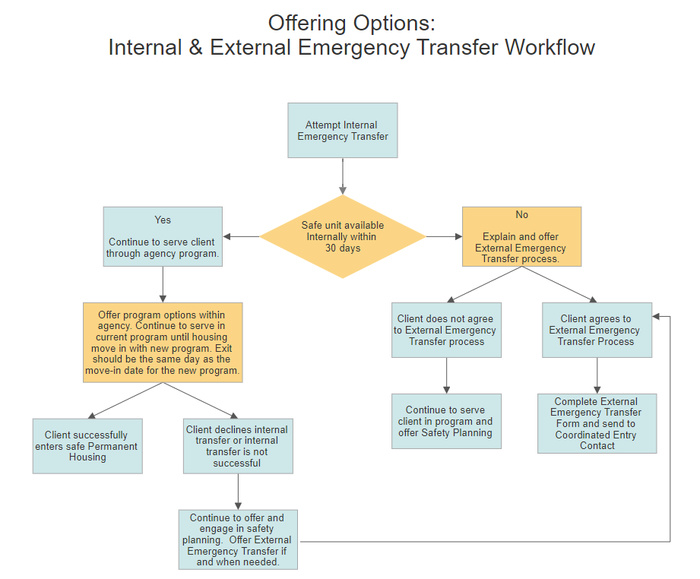

External Emergency Transfer Form
Download the External Emergency Transfer Request form from the ECHO website.
Email the completed form as an attachment to allisonmabbs@austinecho.org.
Internal Emergency Transfer:
Searching for safe housing options internally - within the Agency’s programs.

External Emergency Transfer:
Searching for safe housing options across all programs within the Austin/Travis County Continuum of Care (CoC) homeless system.
IMPORTANT: Depending on what information is provided, the form may need to be sent using an encrypted email.

External Emergency Transfer Request Form

- Provide a narrative documenting all strategies the current program/agency has taken to complete an Internal Emergency Transfer, what the programs would need in order to provide an Internal transfer successfully and provide reasons why an External Emergency Transfer is necessary.
Required
Click or tap here to enter text.

- Current Program Enrollment (referring program) - Select the type of Permanent Housing program:
Required
☐ Permanent Supportive Housing (PSH) ☐ Safe Haven ☐ Rapid Rehousing (RRH)
☐ Joint Transitional Housing -Rapid Rehousing (TH-RRH) ☐ Other

- Immediate Safe Housing: Is the participant unable to access temporary safe shelter and needs assistance finding immediate safe housing options that are temporary? Optional
☐Yes ☐No ☐Unsure

- At program enrollment (referring program) did the participant meet the definition of homelessness as defined by HUD? If so, select all that apply.
IMPORTANT: The referring program is responsible for providing documentation of homeless status from the original program entry/enrollment, if needed to determine eligibility before enrolling into new program
Required
Category 1 or 4: Literally Homeless and/or Fleeing Domestic Violence:
☐Yes ☐No ☐Unsure

Category 2: At-risk of homelessness
☐Yes ☐No ☐Unsure

Chronically Homeless:
☐Yes ☐No ☐Unsure

Resource: HUD Criteria for Defining Homelessness & Recordkeeping Requirements
Resource: HUD Exchange – Chronic Homelessness
If requesting a transfer to a PSH program, do not enter detailed information about chronic homeless status. Original/referring program must be able to verify and provide documentation of homeless status during original program entry that adhere to HUD standards. Eligibility documentation will be given to the new program after the following steps: available units are identified; participant has been offered available options and participant has accepted one of the housing options (if applicable).

- Program Preference for Transfer - Permanent Housing program type. Select all preferred housing types, if any.
☐ Permanent Supportive Housing (PSH) ☐ Safe Haven ☐ Rapid Rehousing (RRH)
☐ Joint Transitional Housing -Rapid Rehousing (TH-RRH) ☐ Other ☐ No Preference

- Suitable Dwelling Size: Review the instructions below and answer the following question based on the household/family composition/size.
Required
Minimum number of bedrooms needed: Click or tap here to enter text.
To determine the minimum # of bedrooms needed, HUD provides guidelines based on the household composition and size. Important: the minimum # of bedrooms the household is eligible for is NOT personally identifying information. Do NOT enter information specific to the # of children or family size – this is considered personal identifying information and may pose a safety risk. Additional information will be collected if the participant selects a program to transfer to.
Minimum # of bedrooms needed for a household is the fewest # of rooms needed to be considered a suitable dwelling size.

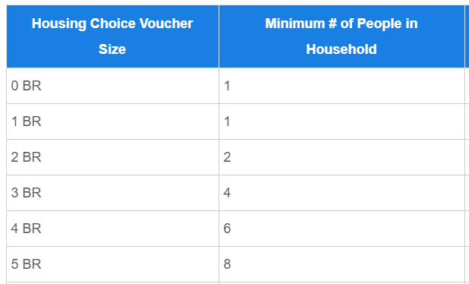 | Suitable dwelling size. Units that are considered a suitable size: must have at least one (1) bedroom or living/sleeping room for each two (2) persons. 24 CFR § 578.75(c). Children of opposite sex, other than very young children, may not be required to occupy the same bedroom or living/sleeping room. 24 CFR § 578.75(c)(1).  - For a single-person household, the minimum number of bedrooms would be 1 or less.  - Children of opposite sex, other than very young children, may not be required to occupy the same bedroom or living/sleeping room.  - Participants should be assisted in choosing a unit with the smallest number of bedrooms needed without overcrowding. Except in limited circumstances (i.e., request for reasonable accommodation, etc.).

- Include any locations, areas, or agencies that may not feel safe:
Optional
Click or tap here to enter text.

- In order to find a program to match the needs of the household requesting the transfer, include any information about safe areas or safe housing types or other service/housing preferences:
Optional
Click or tap here to enter text.

- Subpopulation Focused Program Eligibility:
The following items will help identify if the participant meets eligibility for programs that have specific enrollment requirements. These items are not required and can be refused.

- Current or immediate interest in mental wellness services with Integral Care:
☐Yes ☐No ☐Unsure ☐Refuse

- Interest in services to support people living with HIV/AIDS:
☐Yes ☐No ☐Unsure ☐Refuse

- Household has member(s) age 55+:
☐Yes ☐No ☐Unsure ☐Refuse

- Interested in Transitional Housing with a Victim Service Provider (VSP) agency:
☐Yes ☐No ☐Unsure ☐Refuse

- Interested in a short-term RRH program that provides a maximum three months of rental assistance/financial assistance and case management.
☐Yes ☐No ☐Unsure ☐Refuse

Referring Agency Point of Contact
Required
Name Click or tap here to enter text.
Position: Click or tap here to enter text.
Agency: Click or tap here to enter text.
Email: Click or tap here to enter text.
Phone Number: Click or tap here to enter text.
Secondary Contact Information (optional): Click or tap here to enter text.

External Emergency Transfer Request Forms must be sent to allisonmabbs@austinecho.org

Depending on consent and information provided in the email; it is recommended that submissions be sent using an encrypted email. DO NOT include any identifying information (e.g., name, date of birth, social security number) in the body of the email or attached form. Based on the information entered in the form, Coordinated Entry staff will search for immediate housing options based on basic eligibility criteria and immediately reply to the referring program with the available program options for the household to select from. The referring program is required to continuing serving the participant.

